5355_DISCRETE TRANSFORMS ASSIGNMENT 5

NAME: PAVAI ARCHIMEDES

ST ID:1001233996

PROGRAM:

clc;

close all;

clear all;

p=imread('c:\Users\PAVAI ARCHIMEDES\Desktop\lena512.bmp');

figure (1);

subplot(2,3,1);

imshow(p);

title('Original Lena Image');

DCT=dct2(p);

subplot(2,3,2);

imshow((DCT));

title('DCT of image');

for i=1:1:4

filt=DCT.*filter_mask(512,2^i);

re=idct2(filt);

MSE=sum(sum((double(p)-re).^2))/(512*512);

PSNR=10*log((255^2)/MSE);

subplot(2,3,i+2);

imshow(uint8(re));

Title={num2str(2^i)',': 1 mask used MSE= ',num2str(MSE),'PSNR=',num2str(PSNR)};

title(Title);

end

figure (2);

for i=1:1:4

Reconimg=dct_88(p,2^i);

MSE=sum(sum((double(p)-Reconimg).^2))/(512*512);

PSNR=10*log((255^2)/MSE);

subplot(2,2,i);imshow(uint8(Reconimg));Title={num2str(2^i)',': 1 mask used MSE= ',num2str(MSE),'PSNR=',num2str(PSNR)};

title(Title);

end

function [filter_mask] = mask(size,ratio)

filter_mask=zeros(size);

if ratio==2

for i=1:1:size

for j=1:1:size-(i-1)

filter_mask(i,j)=1;

end

end

elseif (ratio==8 && size==512)

size=size/2;

for i=1:1:size

for j=1:1:size-(i-1)

filter_mask(i,j)=1;

end

end

elseif (ratio==8 && size==8)

size=size/2-1;

for i=1:1:size

for j=1:1:size

if j==size && i==size

filter_mask(i,j)=0;

else

filter_mask(i,j)=1;

end

end

end

elseif (ratio==4||ratio==16)

size=size/(log2(ratio));

for i=1:1:size

for j=1:1:size

filter_mask(i,j)=1;

end

end

end

function [ Recon_image] = dct_88(I,ratio)

Recon_image=zeros(512,512);

for i=1:8:512

for j=1:8:512

for k=1:1:8

for e=1:1:8

temp(k,e)=p(k+(i-1),e+(j-1));

end

end

IDCT88=dct2(temp);

Ifilt=IDCT88.*filter_mask(8,ratio);

I_recons_88=idct2(Ifilt);

for m=0:1:7

for n=0:1:7

Recon_image(m+i,n+j)=I_recons_88(m+1,n+1);

end

end

end

end

end

OUTPUT GRAPH FOR IMAGE:

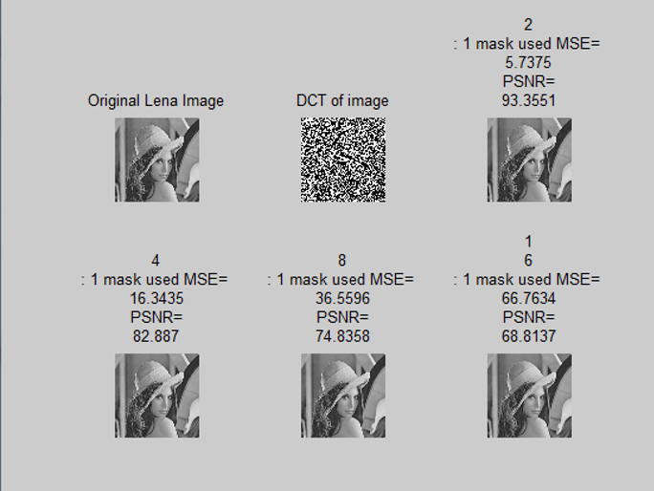

OUTPUT GRAPH FOR RASTER SCAN:

